Comparative LCA of coffee: capsules vs brick pack

AG 2800, Life Cycle Assessment
KTH, Stockholm
16-12-2016
Group 13
Sara Edvardsson, Patrick Henriksson
Fredrick Regnell, Hedvig Winther

Supervisor: Xenofon Lemperos

ABSTRACT
Coffee is one of the most consumed beverages in the world, and after oil, it is the second most valuable and traded product worldwide. Coffee is transported all over the globe as the plantation and consumption is not located in the same parts of the world. The plantations are often located nearby sensitive ecosystems, thus it might have some negative impacts on the surroundings. The huge consumption of coffee makes it an interesting product to investigate. As it is highly unlikely that people would stop drinking coffee, it is interesting to investigate different ways to make and drink coffee. This report investigates the life cycle of conventionally brewed filter coffee, packaged in brick packs, and coffee made from capsules, in order to see which of these two alternatives that has got the least environmental impact. With the help of a literature review, data has been collected for the various life cycle stages, for both coffee products. The data was then entered into SimaPro in order to see the environmental impacts. The results showed that brick packs have got a higher environmental impact than capsules in all impact categories except for metal depletion. Capsules may have a higher metal depletion due to that the capsules are made out of aluminium. The reason for brick packs affecting all other impact categories more is due to that more coffee beans are needed for making a cup of filter coffee than a cup of capsule coffee. The conclusion, from an environmental point of view, is thus that the consumers should choose capsules over brick packs.

Contents
1. Introduction 1
1.1 Goal and Scope 1
1.2 Functional Unit 1
1.3 System Boundaries 2
1.4 Assumptions and Limitations 2
1.5 Impact Categories and Impact Assessment Method 3
1.6 Normalisation and Weighting 3
2. Life cycle inventory analysis 4
2.1 Process Flow Chart 4
2.2 Data 5
2.2.1 Growth, harvesting and processing 5
2.2.2 Filter coffee 6
2.2.3 Coffee brewer 6
2.2.4 Packaging filter coffee 6
2.2.5 Filter 7
2.2.6 Capsules 8
2.2.7 Transport of coffee 9
2.2.8 Waste management 9
3. Life cycle interpretation 10
3.1 Results 10
3.2 Sensitivity Analysis 15
4. Discussion 16
5. Conclusion 18
References 19
APPENDIX 1. I
APPENDIX 2 II
APPENDIX 3 V

1. Introduction
The most consumed beverage in the world is coffee (Howstuffworks, 2016), with a consumption of 1.6 billions cups a day (Thomas, 2013). Coffee is the one of the most valuable and traded product in the world and ranks just below oil. The production of coffee is in most cases located in another part of the world than where the consumption of coffee is. Plantations of coffee are usually located in tropical and equatorial areas (Salomone, 2003). These plantations are often located in or nearby sensitive ecosystems, leading to coffee having possible impacts on the surrounding environment (Moore, 2016).

The large consumption of coffee makes it an interesting product to investigate. Several studies have been conducted in order to examine the environmental impact of all the stages of the product chain for coffee. Most of these studies are single systems LCA, where the interest lay in the investigation of the total environmental impact from coffee. Two examples of such studies are, firstly Salinas report Life Cycle Assessment of Coffee Production (2008), which is an LCA about green coffee production on a farm in Guatemala. The second one is Coltro et al. report Environmental Profile of Brazilian Green Coffee (2006), which is a life cycle inventory about Brazilian coffee. As there are several different coffee sorts and packaging types, comparative studies have also been made. One example of such a study is a comparison between bulk coffee and single-serve coffee by Quantis (2015).

Many of the studies made focuses on the production step, including growth, harvesting and roasting. In some cases the focus is on the materials for different packaging of coffee. This study will have a different approach, as it targets the consumers. The study will compare brick packs for filter coffee with capsules for espresso coffee, as these are two popular ways of drinking coffee.

1.1 Goal and Scope
The goal of the study is to determine the environmental impact of two ways of packaging and consuming coffee. A comparative and accounting LCA will be carried out with the help of average data collection. The two ways of packaging coffee are brick packs for filter coffee and capsules for espresso coffee. The entire life cycle will be assessed for both products, thus the environmental impact by growing, harvesting, processing, and consuming coffee will also be investigated.

Intended application is to give more information to the consumer, which is the intended audience of this study, so that the consumer gets more insight on the environmental impact of coffee and its packaging. From this, the consumer can make more conscious choices when purchasing and consuming coffee. In order to establish the sensitivity of the life cycle of coffee, which is packaged in two different ways, a sensitivity analysis will be constructed.

1.2 Functional Unit
The functional unit is 1000 cups of coffee. The functional unit of 1000 cups of coffee was chosen instead of for example 1000 litres, because it would be easier for the consumer to understand and relate to the result from this study. A consumer can either choose to drink a cup of filtered coffee or a cup of coffee from capsules. The amount of 1000 instead of 1 is due to that 1 would generate significantly smaller numbers to work with. The ratio will still be the same.

1.3 System Boundaries
The processes which are included are: growth and harvesting of the coffee bean, transport between the different processes, processing (roasting and grinding), packaging and the use of the coffee machines to make coffee. Waste management is also included in the system boundaries. All of these processes are considered to be in the foreground, whereas the inputs, which are most commonly electricity, water and such, and the outputs of carbon emissions and waste are considered to be in the background.

The geographical boundaries are firstly where the growth of the beans happens, which is in São Paulo, Brazil. Transportation of the beans will be to Lisbon and Avenches in Europe and the end consumer will be in Karlstad, Sweden.

One cut-off criteria which can be identified, is the making of the coffee machines, which will not be included. It is considered that the coffee machines are not a part of the overall environmental impact of coffee. However, this could perhaps be considered in a more thorough LCA about coffee consumption and its environmental impact.

The allocation problems that occur are for growth, harvesting, processing, transport and waste. Allocation for growth, harvesting and processing is solved in SimaPro as the calculations there are by mass. The same is also applied for the allocation problem in regards to waste. The allocation problem in regards to transport is solved in SimaPro by entering the distance of the transported goods multiplied by the weight of the goods.

1.4 Assumptions and Limitations
The basic assumptions, which are used is firstly that the coffee, which are in the two packaging types is from the same type of bean. The bean of interest is grown, harvested and processed in Brazil, São Paulo. The transport of the coffee beans goes to Lisbon by ship and then to Karlstad in Sweden by truck. The coffee beans aimed for filter coffee goes directly to Karlstad from Lisbon, whereas the coffee beans that are meant for the coffee capsules travels by truck to Avenches in Switzerland, before going to Karlstad. The choice of Karlstad is due to that a Swedish coffee company, Löfbergs Lila, has there own production there.

For the process of brewing the coffee two coffee machines were chosen, one that can be used for brewing capsules and one for brewing filter coffee. For the coffee machine, which takes capsules, the Nespresso machine Pixie C60 was chosen as it was rated the most popular on Prisjakt (2016b). Moccamaster KBG741 AO was rated most popular on Prisjakt (2016a) for brewing filter coffee and was therefore chosen. The lifetime of these machines are not considered, as their material and production are not included in the LCA. The electricity used by the two machines is assumed to come from a Swedish electricity mix.

1.5 Impact Categories and Impact Assessment Method
The impact assessment method that has been chosen is the ReCiPe method (Hierarchist). The ReCiPe method uses the life cycle inventory analysis results and turns them into indicator scores, which are more limited in number. The meaning of the indicator scores are that one can see the corresponding impact on chosen environmental impact categories. The indicators are determined through three endpoint indicators as well as eighteen midpoint indicators. The three endpoint indicators are calculated to be able to better understand the midpoint indicators. Damage to human health is one of these three endpoint indicators. Damage to resource availability and damage to ecosystems are the other two endpoint indicators. The ReCiPe (Hierarchist) method includes all eighteen different midpoint indicators (ReCiPe, 2015).

The eighteen midpoint indicators, which are available when choosing ReCiPe (Hierarchist) for modelling, are (ReCiPe, 2015):
- Human toxicity
- Ozone depletion
- Particulate matter formation
- Agricultural occupation
- Freshwater ecotoxicity
- Climate change
- Marine ecotoxicity
- Metal depletion
- Ionising radiation
- Water depletion
- Terrestrial acidification
- Photochemical oxidation
- Fossil depletion
- Terrestrial ecotoxicity
- Marine eutrophication
- Freshwater eutrophication
- Natural land transformation
- Urban land occupation

For a general view of the impact from the two packaging types all eighteen of the impact categories have been chosen.

1.6 Normalisation and Weighting
Normalisation is used as a tool in LCA to give a broader context and the magnitude of impact of a particular impact category. The normalisation is calculated by using a reference value (Qurran, 2015). In this study normalisation will be used in order to give more importance and understanding to the results where one will be able to see what impact categories that are mostly affected. Weighting will not be considered, it can however be used for further investigation of the two packaging types.

2. Life cycle inventory analysis

2.1 Process Flow Chart
In Figure 1, one can see the process flowchart for the life cycle of the coffee, which is then packaged as capsules and brick packs.
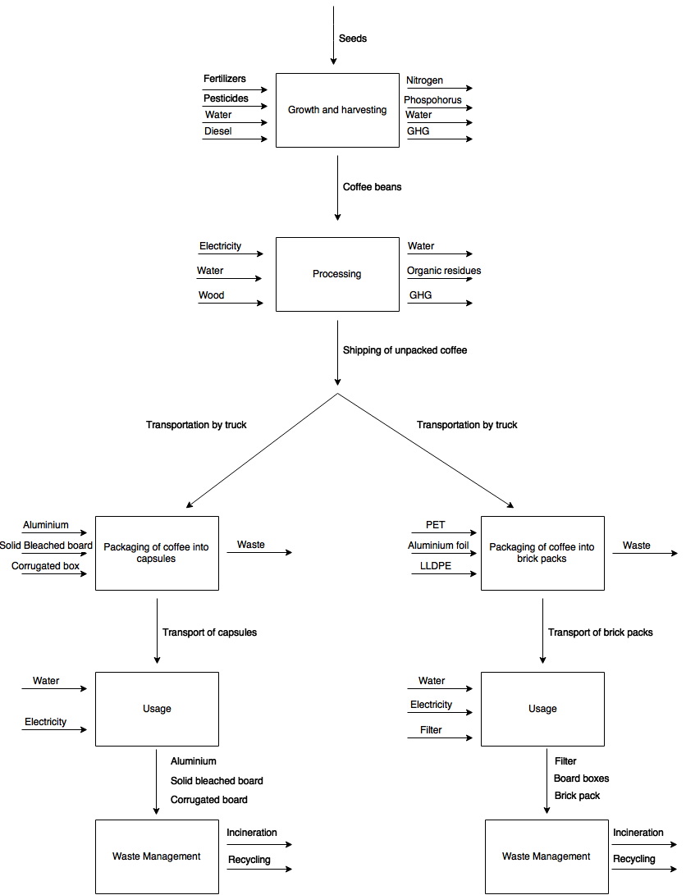
Figure 1. Flowchart for the life cycle of capsules and brick packs.

2.2 Data

2.2.1 Growth, harvesting and processing
As stated earlier, the growth, harvesting and processing is assumed to be located in São Paulo, Brazil. This assumption was made as Brazil is the biggest producer of coffee beans in the world (Coltro et al., 2006). The growth, harvesting and processing steps have been included in the LCA as the functional unit of 1000 cups of coffee results in that more coffee is needed for the coffee, which is packaged as brick packs compared to the coffee made from capsules. This is partly because a certain amount of the drinkable filter coffee is assumed to go to waste, but mostly because more grounded coffee is needed for one cup of filter coffee than a cup of capsule coffee. This will be further discussed later in the report.

Residues are also created during the processing step of the coffee beans. An input of 1000 kg of coffee beans creates 757 kg of organic residues, meaning that 24.3 % will become coffee beans, which can be used in the products (Coltro et al., 2006). This factor is considered when calculating the impact from the capsules and the brick packs. Furthermore, the electricity and wood needed in these three different steps are mainly used in the processing step (Coltro et al., 2006), which is why the data for electricity and wood is located only to the processing step. Other inputs are fertilizers, water, diesel, pesticides etcetera. All inputs included in growth, harvesting and processing are stated in table 1 below. The calculations made for estimating the inputs are further stated in Appendix 1.

Table 1. Inputs for brick packs and capsules for the growing, harvesting and processing steps (Coltro et al., 2006)
Input | Input capsules | Input brick pack
Water (kg) | 268.28 | 362.41
Diesel (kg) | 2.2 | 2.98
Fertilizers as NPK (kg) | 6.43 | 8.68
Total fertilizer (kg) | 21.37 | 28.87
Correctives (Ca, Mg) (kg) | 6.4 | 8.65
Pesticides (kg) | 0.23 | 0.32
Annual land use (ha) | 0 | 0
Wood (kg) | 8.63 | 11.66
Electricity (MJ) | 15.15 | 20.47

2.2.2 Filter coffee
For the filter coffee it is assumed that one cup of coffee is 1.5 dl. This will, as the functional unit is 1000 cups, result in 150 litres of coffee. One cup of coffee is assumed to require 7 g of coffee, which will result in 7 kg of coffee for 1000 cups. One package of coffee is 500 g, which will give us 14 packages of coffee (Löfbergs Lila, n.d.).

Another assumption for the filter coffee is that for each brewing there is 10% extra coffee being made. This will account for the coffee that is thrown away and not being drunk by the consumer. When including this 10%, which goes to waste, one would have to brew 165 litres of coffee to get 1000 cups, which will give 15.4 packages of coffee.

2.2.3 Coffee brewer
As stated earlier the chosen coffee brewer was the Moccamaster KBG741 AO. The effect of this coffee machine is 1520 W (Prisjakt, 2016a). The estimated cups for each time one brews coffee is 4 cups. To get 1000 cups one would have to brew coffee 250 times. The amount of time that it takes to brew one time is approximately 6 minutes (Moccamaster, n.d.). The amount of energy, as well as the data for the coffee machine, needed to brew 1000 cups of coffee, can be seen in table 2. The waste factor of 10 additional percent is also included for the amount of water needed for 1000 cups of coffee as this would require more water. is 10%.

Table 2. Data for coffee machine used for filter coffee (Prisjakt, 2016a), (Moccamaster, n.d.)
Material | Amount | Waste factor
Energy needed for the coffee machine (W) | 1520 | -
Time for making coffee (s) | 360 | -
Assumed cups for each brewing | 4 | -
Amount of brewing times for making 1000 cups of coffee | 250 | -
Total time for making 1000 cups of coffee (s) | 90000 | -
Total energy use (J) | 136800000 | -
Conversion ratio Joule to kWh | 3600000 | -
Total energy use (kWh) | 38 | -
Amount of water needed for 1 cup of coffee (dl) | 1.5 | -
Amount of water needed for 1000 cups of coffee (dl) | 1500 | 1650

2.2.4 Packaging filter coffee
Coffee that is to be filtered can have numerous ways of being packaged. It can be packaged through steel canisters, steel cans, plastic canisters, laminate bags or through brick packaging (Franklin Associates, 2008). It is assumed here, as stated earlier, that the coffee used as filter coffee is packaged with brick packs. The weight of the package can be seen in table 3 and the weight for the different materials of the total 14 packages can be seen in table 4. The waste factor is also included in both cases.

Table 3. Package weight (Franklin Associates, 2008)
Package material | Material weight (g) | Waste factor
368 g brick pack | 12.30 | -
500 g brick pack | 16.71 | -
14 (500g) brick packs | 233.97 | 257.36

Table 4. Weight of the different materials in 14 packages (Franklin Associates, 2008)
Material | Percentage (%) | Weight (g) | Waste factor
PET | 15 | 35.10 | 38.60
Aluminium foil | 20 | 46.79 | 51.47
LLDPE | 65 | 152.08 | 167.29

2.2.5 Filter
The filter, which is assumed to be used in this case, is the Abaca filter. Abaca filter contains abaca fibre, softwood and PE (polyethylene) (Quantis, 2015). The weight of these materials in 1 filter and for all 1000 cups, assuming the 4 cups, which are brewed each time, can be seen in table 5. Abaca fibre could not be found in SimaPro, whereupon paper was assumed instead. Softwood was excluded, as it was not found in SimaPro, neither as a product nor as something similar. The amount of softwood in the filter is also quite low where after it was decided that it could be excluded from the simulation in SimaPro.

Table 5. Material in abaca filter and their weight (Quantis, 2015)
Material | Weight 1 filter (g) | Weight of filter for 1000 cups (g)
Abaca | 0.202 | 50.5
Softwood | 0.0224 | 5.6
PE | 0.056 | 14

The filters are packaged in a board box. The board boxes contain 100 filters each, which would mean a requirement of three packages, 300 filters in total, for brewing coffee 250 times. The weight of the box can be seen in table 6.

Table 6. Weight of package for filters (Quantis, 2015)
Filter packaging | Weight 100 pack (g) | Weight for 1000 cups (300 filters) (kg)
Board box | 30 | 0.09

2.2.6 Capsules
One capsule is equal to one cup of coffee and as the functional unit is 1000 cups of coffee, 1000 capsules will be required. One cup of coffee, when using capsules, requires 1.1 dl water (Nespresso, n.d.). It is assumed that the losses when making coffee using capsules is negligible. The capsules chosen here is made out of aluminium. The aluminium capsule is considered as the primary packaging, the secondary packaging is made of solid bleached board, the tertiary package is made out of corrugated board (Quantis, 2011). Table 7 shows the material needed for one capsule.

Table 7. Data for primary, secondary and tertiary packaging for capsule coffee (Quantis, 2011)
Material | Weight per capsule (g) | Weight for 1000 cups (g)
Aluminium | 1.1 | 1100
SBB (solid bleached board) | 1.6 | 1600
Corrugated box | 0.8 | 800

One capsule contains 5.7 g of coffee (Hoffman, 2016), which means that the amount of coffee per functional unit will be 5.7 kg.

In order to brew the coffee there is a need for a coffee machine that can take capsules. All data for the water needed, time for brewing, as well as the energy consumption to make 1000 cups of coffee is presented below in table 8.

Table 8. Data for the coffee machine Nespresso machine Pixie C60 (Prisjakt, 2016b) (Nespresso, n.d.)
Material | Amount
Energy needed for the coffee machine (W) | 1260
Time for heating water tank (s) | 25
Time for making the coffee (s) | 30
Amount of capsules | 1000
Total time for making 1000 capsules (s) | 55000
Total energy use (J) | 69300000
Conversion ratio Joule to kWh | 3600000
Total energy use (kWh) | 19,25
Amount of water needed for 1 cup of coffee (dl) | 1.1
Amount of water needed for 1000 cups of coffee (dl) | 1100

2.2.7 Transport of coffee
The coffee is assumed to be consumed in Karlstad, Sweden. As the coffee beans comes from the same plantation and processing industry, both the filter coffee and the capsule coffee will be shipped from São Paulo to Lisbon. From Lisbon the filter coffee and capsule coffee will take different paths. The filter coffee will be transported to Karlstad where it will be packaged and then consumed in Karlstad. The capsule coffee will be transported from Lisbon to Avenches, as the capsules are made in Avenches (Nespresso, 2010a). The coffee is then packaged into the capsules and then transported to Karlstad to be sold and consumed. The distance for the transportation between the different places are stated below in table 9.

Table 9. The distance between the different locations of the journey of the coffee
Locations | Distance (km)
São Paulo to Lisbon (Time and Date, 2016) | 7925
Lisbon to Avenches (Google maps, 2016a) | 1968
Lisbon to Karlstad (Google maps, 2016b) | 3508
Avenches to Karlstad (Google maps, 2016c) | 1809

2.2.8 Waste management
It is assumed that parts of the solid bleached board, the corrugated box, and the board boxes goes to recycling. Energy consumption for recycling paper was added in SimaPro to make it more realistic, as the waste scenario for paper in SimaPro does not include the energy, which is needed when recycling. Recycling of paper requires 22 million BTU per tonnes recycled paper (Kinsella, 2012). 1 BTU is about 1055 J where the amount of energy during recycling in this case will be equal to 23.2 MJ energy per kilogram recycled paper.

The same problem applies for aluminium, which means that energy consumption for recycling aluminium also is needed. Recycling of metal requires 6 909 MJ energy per tonnes metal that is produced (The Aluminium Association, 2011), which is equal to 6.9 MJ energy per kilo metal that is produced. This numbers will be used for aluminium in order to make the waste scenario more realistic.

For the waste management of coffee for capsules, 50% of all the paper and 80% (Nespresso, 2010b) of all the aluminium has been assumed to go to recycling, the rest to goes to incineration. For the filter coffee, 50% of the paper has been assumed to go to recycling, where the rest goes to incineration. Further waste for filter coffee is the coffee-grounds and the leftover coffee in liquid form. The coffee-grounds is likely to go to biogas and the liquid coffee would go down the drain and therefore be considered as wastewater. The coffee-grounds and wastewater could not be included in a realistic way in SimaPro and is therefore excluded from the waste scenario.

3. Life cycle interpretation

3.1 Results
The impact from capsules and brick packs on the eighteen impact categories are shown in figure 2, 3 and 4. The capsules are represented by the grey colour and the brick packs as the green colour. The largest differences between the two packaging types are first and foremost the materials used for packaging as well as energy and water needed. Another thing, which is different, is the transport route. These parameters may affect the results.

The characterised results, figure 2, shows the relative impact from the two packaging types. Figure 2, with the characterised results, shows that capsules has a relative lower impact on all impact categories except for one, which is “metal depletion”. This also stands true for the normalised results in figure 3 and 4. According to the normalised results, which can be seen in figure 2, there are three main impact categories, which are affected the most. These three impact categories are “freshwater ecotoxicity”, “marine ecotoxicity” and “natural land transformation”. On all three impact categories brick packs is the one that has got the highest impact. If one excludes the long-term emissions, figure 4, the impact category “natural land transformation” is the impact category, which is the far most affected by both packaging types.

In SimaPro, for the normalized results, in regards to the impact category “natural land transformation”, the process with the highest impact is the growing and harvesting where the usage of diesel contributes the most. Packaging has got a near similar impact as the growing and harvesting, where transport contributes the most. This stands true for both capsules and brick packs. In regards to the impact category “marine ecotoxicity”, the process having the largest impact is again the growing and harvesting, which can be seen for both packaging types. Electricity is also contributing to a large extent. The difference here is that electricity is used, in regards to capsules, not only for the machine but also for recycling, which is not the case for brick packs. Brick packs only have a high usage of electricity for the use of the machine. For the impact category “freshwater ecotoxicity”, the electricity is again contributing to a large extent, which for both packaging types are for the usage and some for the waste management for the capsules.

Enlarged figures of figure 2, 3 and 4 can be found in Appendix 2.
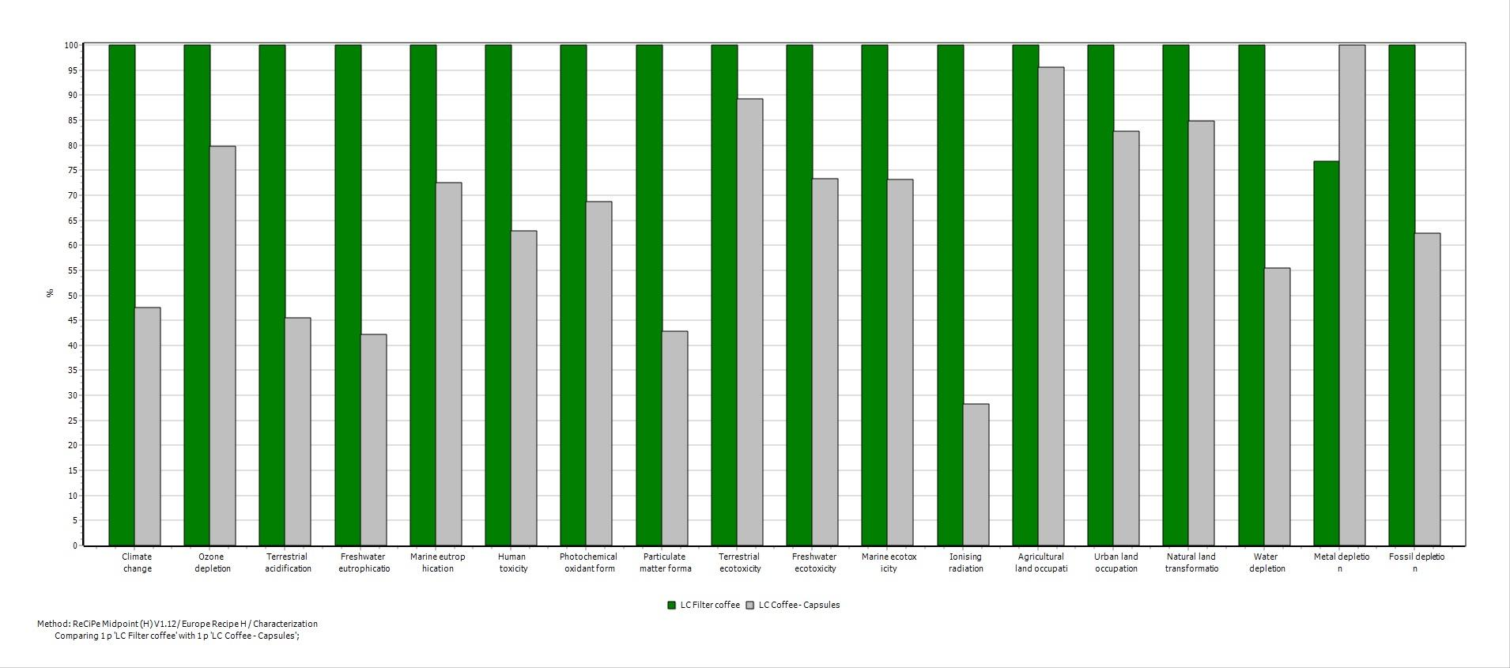
Figure 2. Characterisation of the eighteen impact categories.
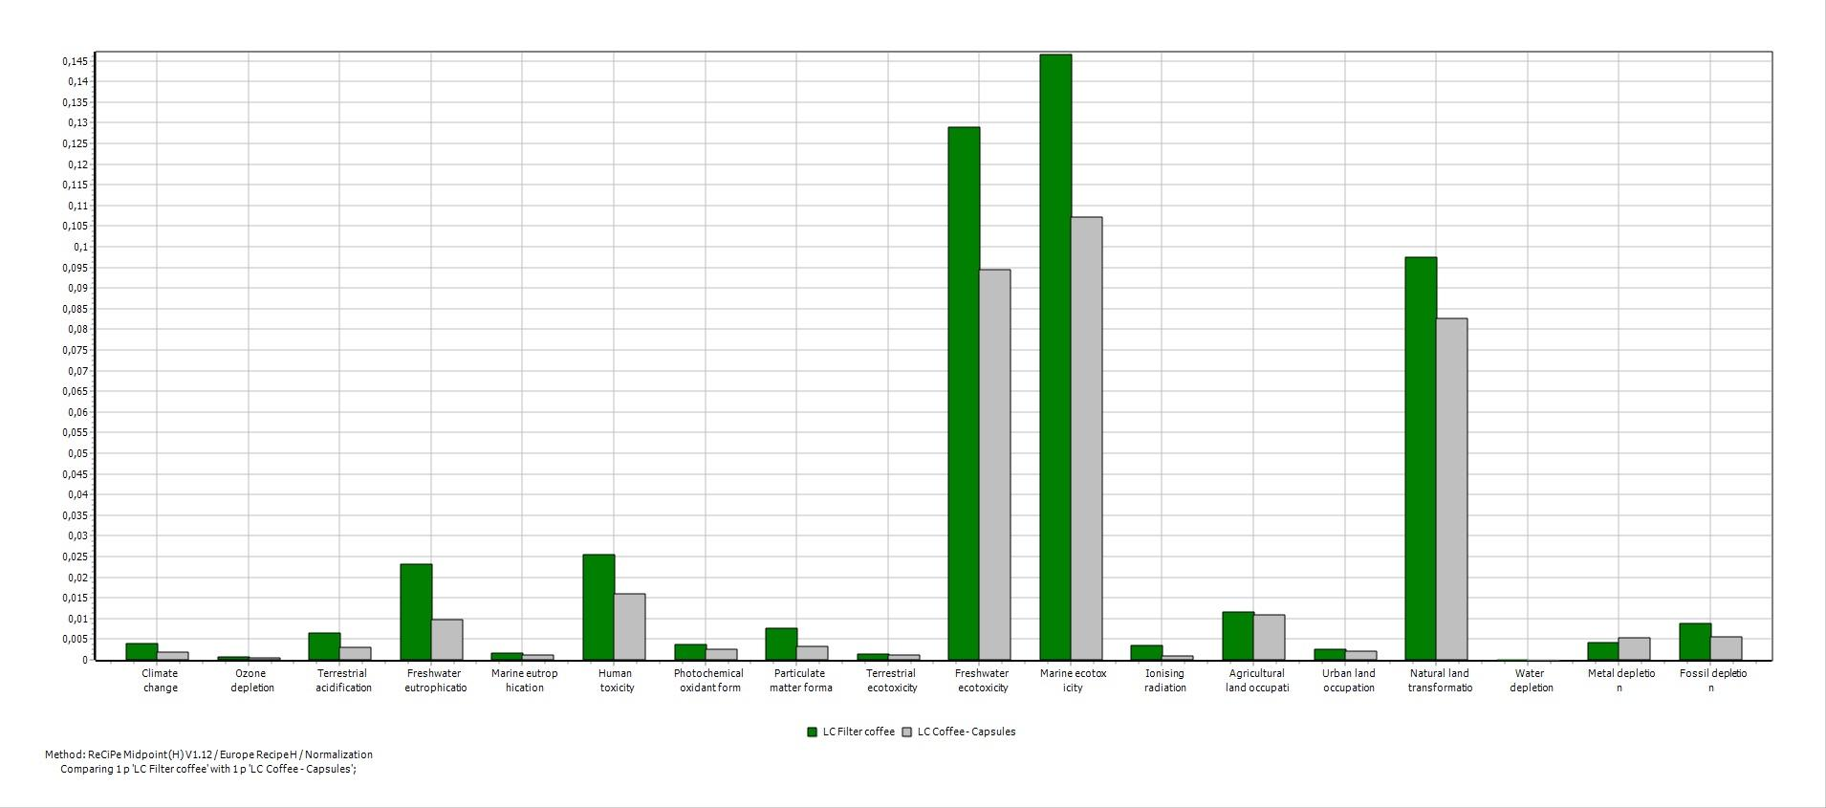
Figure 3. Normalised results of the eighteen impact categories.
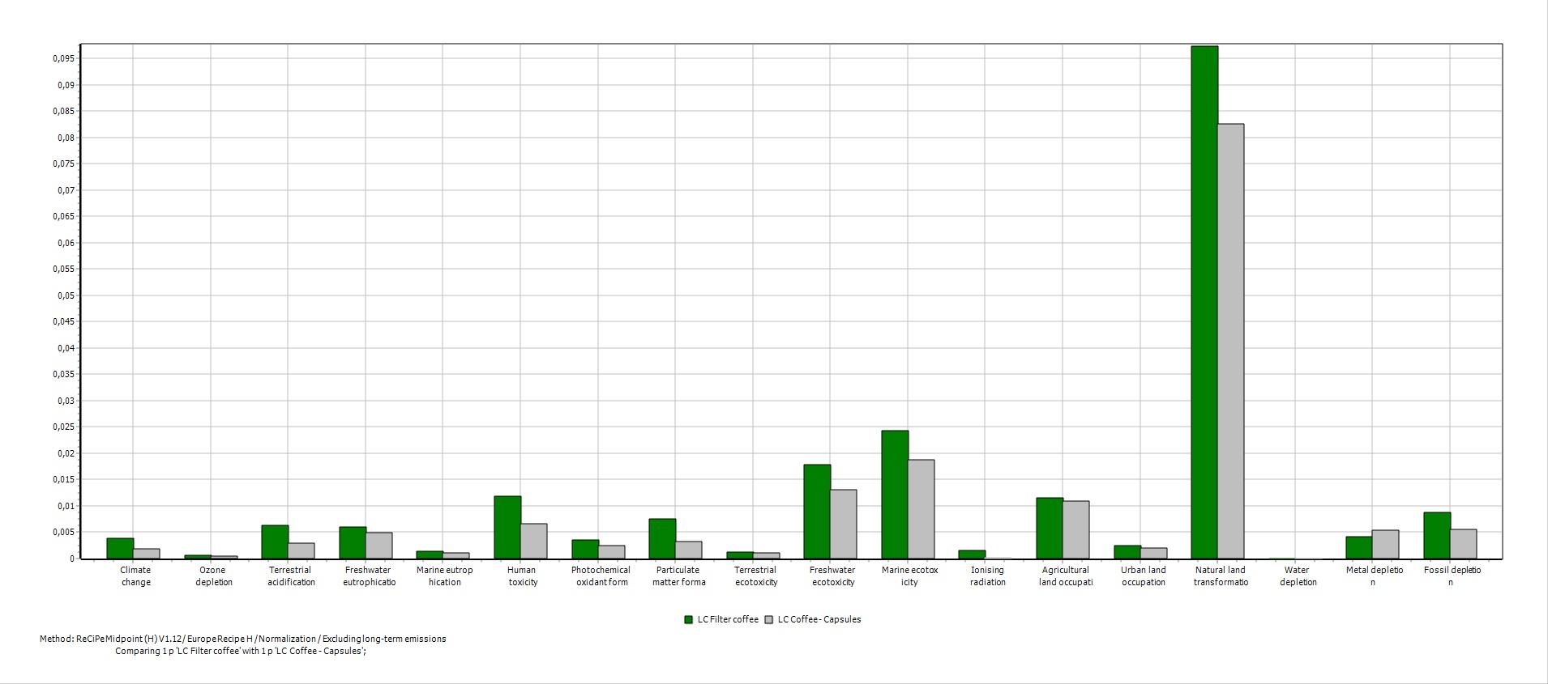
Figure 4. Normalised results excluding long-term emissions of the eighteen impact categories.

The flowcharts below, Figure 5, 6, 7 and 8 are presented from the perspective of the impact category "climate change" which is because climate change is expressed as carbon dioxide equivalents and might be easier to interpret for the target group (consumers). For comparison, the most affected impact category "marine ecotoxicity" is measured in 1,4-DB equivalents (1,4-dichlorobenzene), which might be less comprehensive for consumers. Which unit that is used when compiling the LCA is essential. If one were to look at “marine ecotoxicity” the most important part is usage phase (electricity). Impacts from other specific parts are insignificant in comparison to the electricity in the usage phase. Other process stages would perhaps be out of greater importance if another unit had been chosen.

Figure 5 and 6 visualise the life cycle for the capsule coffee. Figure 5 shows that the largest impacts comes from "growing and harvesting" when producing capsule coffee. Growing and harvesting are, however, impacted by several substeps (fertilizers, irrigation and etcetera), which can be seen in figure 6. The largest impact comes from "transport" for the LCA of capsules, which can be seen in both figure 5 and 6.

Enlarged images of figure 6 and 8 can be seen in Appendix 3.

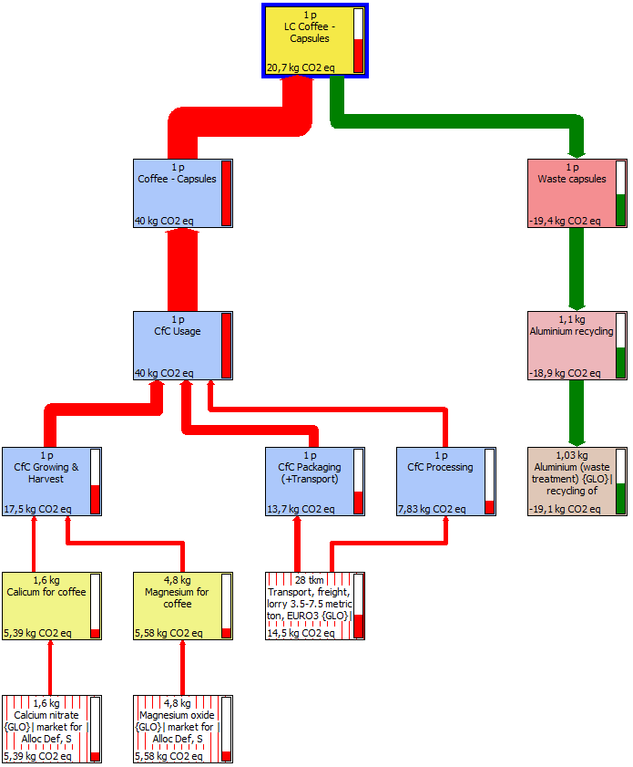
Figure 5. Life cycle for coffee packaged with capsules with 10% cut-off.

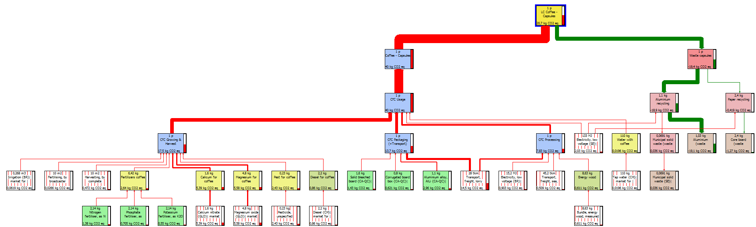
Figure 6. Life cycle of coffee packaged with capsules with 0% cut-off.

The impacts for filter coffee basically origins from the same sources as capsules coffee. The largest impact comes from "growing and harvesting", which can be seen in figure 7 and 8. Again, the same as for capsules, it is "transport" that has got the largest impact. The flowcharts for capsule and filter coffee, figure 5, 6, 7 and 8, are similar. Differences that can be seen in the figures are the materials used for the packaging and the waste scenario.

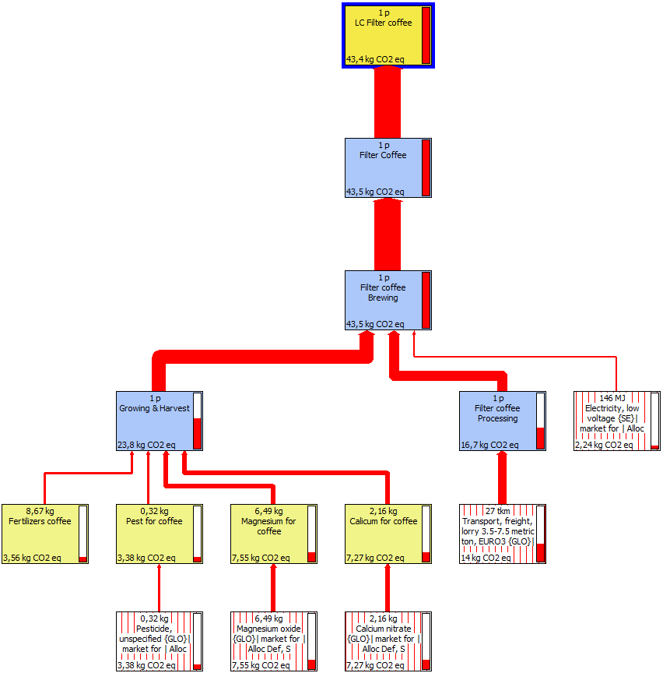
Figure 7. Life cycle for coffee packaged as brick packs with 5% cut-off.

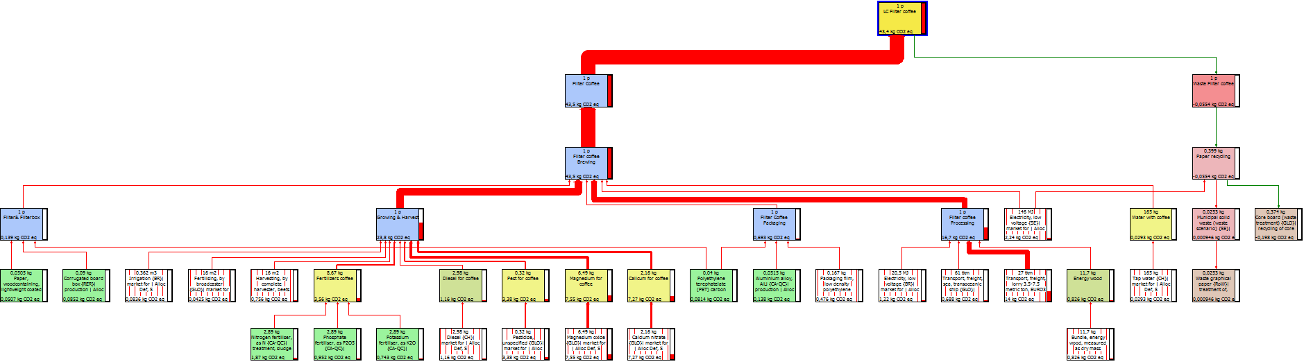
Figure 8. Life cycle for coffee packaged as brick packs with 0% cut-off.

3.2 Sensitivity Analysis
The transport route for the coffee is one parameter that can vary widely, because of for example, change of country where the coffee is being produced, and would therefore have a large sensitivity in the system. Another parameter, which can be considered for its sensitivity, is the waste of filter coffee, as there are no exact measures of how much coffee that is being thrown away. For the sensitivity analysis, two scenarios were created; one based on changes in transport and one based on changes in waste.

Scenario 1: The capsules were assumed to be packed in Sweden instead of Switzerland, making the transport by truck go directly to Karlstad from Lisbon.

Scenario 2: The previously assumed waste scenario of 10% for brick packs was changed to no waste, making the total production of coffee beans for filter coffee smaller. This then affected all the subassemblies in the production chain, resulting in less of an environmental impact. Altered values for the growing and processing are presented in Appendix 1.

Scenario 1 and 2 are both included in life cycle impact assessment of “coffee capsules sensitivity” and “filter coffee sensitivity”.

The different results from both the original life cycles and the ones after the sensitivity changes are presented in Figure 9, 10 and 11. The sensitivity analysis generates a smaller environmental impact for both types of coffee packages compared to the original life cycles. Figure 10 shows that for the area "agricultural land occupation", both values for coffee from capsules have a greater impact than brick packs for filter coffee after the sensitivity analysis. However, all three figures show that regardless of the different alterations, filter coffee has a greater overall environmental impact than coffee from capsules.

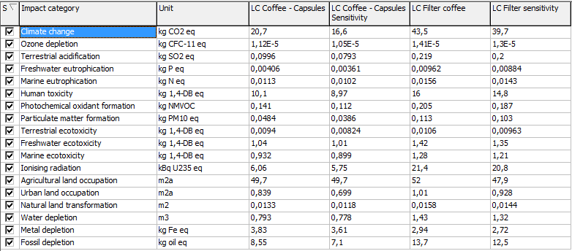
Figure 9. Characterised life cycle impact assessment showing impact categories and four scenarios; coffee capsules, coffee capsules sensitivity, filter coffee, filter coffee sensitivity.

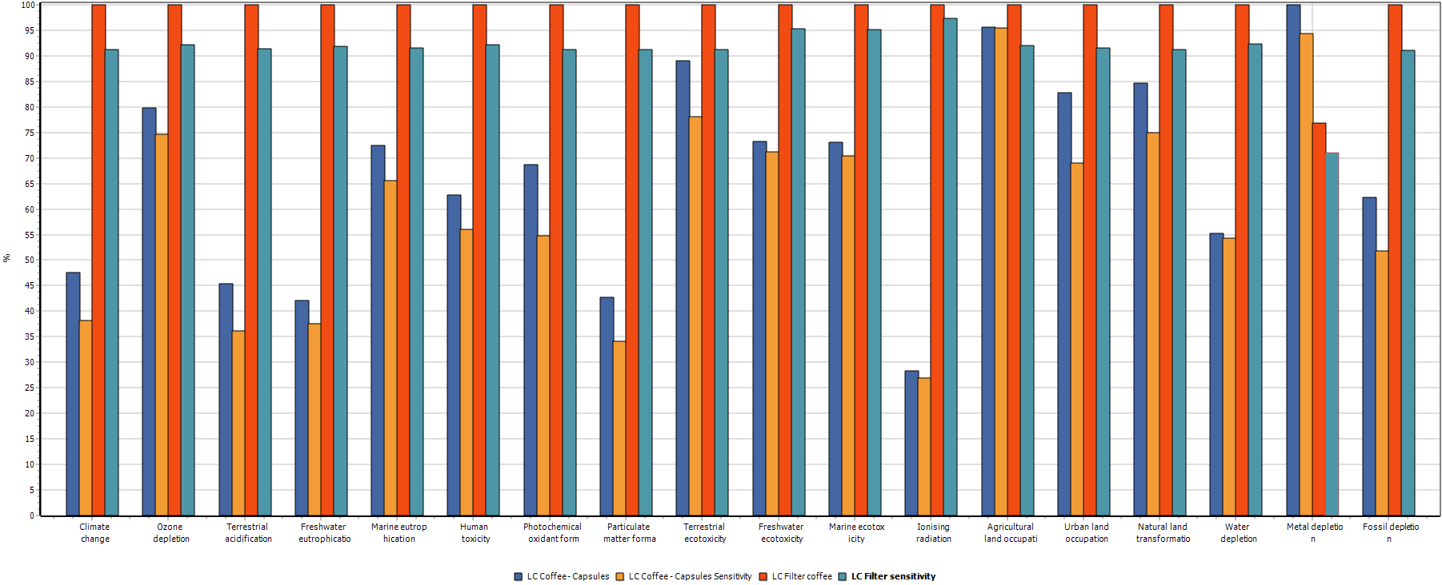
Figure 10. Characterised life cycle impact assessment showing impact categories and four scenarios; coffee capsules, coffee capsules sensitivity, filter coffee, filter coffee sensitivity.

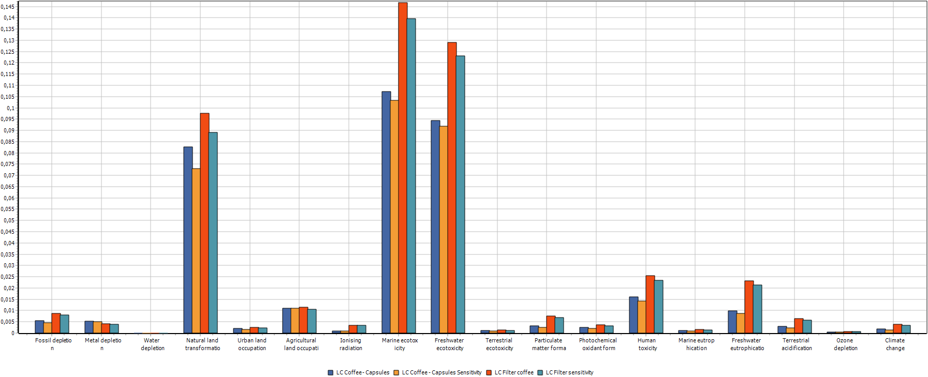
Figure 11. Normalised life cycle impact assessment showing impact categories and four scenarios; coffee capsules, coffee capsules sensitivity, filter coffee, filter coffee sensitivity.

4. Discussion
As seen in figure 2, filter coffee has the largest environmental impact for all impact categories except for metal depletion. That metal depletion is larger for the capsule coffee is due to that the capsules are made of aluminium. That filter coffee has the largest environmental impact for the rest of the impact categories is probably due to that more coffee beans are needed for one cup of filter coffee (7g) than for capsule coffee (5.7g), and the difference becomes even greater once the waste factor of 10% for filter coffee is accounted for. The need for more coffee is directly linked to that more beans are grown, harvested, processed and transported, resulting in a greater environmental impact. The filter coffee also requires more energy in the usage phase, as the coffee machine requires more electricity and because it takes a longer time to brew the coffee. However, the usage phase does not have a large part in the LCA compared to for example transport and harvesting.

The impact categories that are most affected for both the capsules and the brick packs are "freshwater ecotoxicity" and "marine ecotoxicity". When excluding the long-term emissions the most affected impact category is "natural land transformation". Freshwater and marine ecotoxicity is, therefore, dependent on the time perspective, which could be connected with bioaccumulation. Toxins can accumulate over time and the recovery rate might be low, depending on the active substance. If measures would be implemented in the coffee industry in order to lower the environmental impacts, the focus should in a short-term perspective be on “natural land transformation” and in the long term on “freshwater ecotoxicity” and “marine ecotoxicity”. This is in regards to which areas coffee has the largest impact in absolute terms. This does however not mean that these environmental impacts are the most urgent ones, neither the most important ones. But as weighting is not included in this project, conclusions have to be drawn from the quantitative analysis.

The reliability of the result can be discussed as a lot of assumptions have been made. It is possible that the coffee in capsules need to be more finely ground than filter coffee, which would add a step that would increase the environmental impacts for capsule coffee. Furthermore, transportation has been assumed to take the shortest path to Europe, which means that the ship would dock in Lisbon. This would probably be necessary for the coffee beans used in the capsules as the capsules are produced in Avenches, Switzerland. For the filter coffee, on the other hand, it would make more sense if the coffee beans were shipped all the way to Sweden and thereby lower the environmental impacts from transportation. Another factor that could lower the environmental impact from filter coffee is if the coffee-ground was included in the waste scenario and handled as green waste. The green waste could then become biogas and would therefore give a positive effect to the filter coffees’ total life cycle. There are several aspects that could be considered in this project as there might be more differences between filter coffee and capsule coffee than what has been accounted for. To include all these possible differences would not feasible in this project due to lack of data and knowledge, and due to lack of time to obtain more of those parameters.

From a strictly environmental perspective, consumers should choose capsule coffee over filter coffee. However, there are other aspects when choosing coffee that is not included in an LCA that would affect the choice. One of these aspects is the taste and quality of the coffee. Consumers who do not like the taste of capsule coffee will not choose to buy it. Economic incentives are also an important part when it comes to the choice of coffee. Capsules for coffee could perhaps be more expensive than brick packs for filter coffee, which would be an incentive for a lot of people to choose filter coffee over capsule coffee. On the other hand, capsule coffee is considered as a more exclusive coffee, and might possibly also provide another flavour. The environmental perspective can, however, add another dimension to the consumers’ choice of coffee. Environmental awareness is increasing in society, and the result from this LCA would enable the consumers to make more conscious choices.

5. Conclusion
The most affected impact categories are “freshwater ecotoxicity”, “marine ecotoxicity”, and “natural land transformation” for both filter coffee and capsule coffee. Both of the coffee sorts have similar environmental impact, the difference lies within the different packaging materials and the amount of coffee beans needed. Since more coffee beans are needed in order to make filter coffee compared to capsule coffee, more resources are required in the life cycle for filter coffee. This results in filter coffee having a higher environmental impact. Consumers should therefore, from an environmental perspective, choose capsule coffee over filter coffee.

References
Coltro L., Lúcia M., Olivieria P., Paulo J., Kletecke B and Kletecke R. 2006. Environmental Profile of Brazilian Green Coffee. CTEA - Packaging Technology centre/ ITAL Institute of Food Technology, São Paulo, Brazil. DOI: 10.1065/lca2006.01.230

Franklin Associates. 2008. LCI summary for eight coffee packaging systems. Online <https://plastics.americanchemistry.com/LCI-Summary-for-8-Coffee-Packaging-Systems/> Accessed 2016-11-29

Google maps. 2016a. Lisbon to Avenches. Online. <https://www.google.se/maps/dir/Lissabon,+Portugal/Avenches,+Schweiz/@42.449532,-10.0398347,5z/data=!3m1!4b1!4m14!4m13!1m5!1m1!1s0xd19331a61e4f33b:0x400ebbde49036d0!2m2!1d-9.1393366!2d38.7222524!1m5!1m1!1s0x478e73b108636355:0xcf438855c0a87e2f!2m2!1d7.0427075!2d46.8806009!3e0> Accessed 2016-11-29

Google maps. 2016b. Lisbon to Karlstad. Online
<https://www.google.se/maps/dir/Lissabon,+Portugal/Karlstad/@48.7136457,-6.7816552,5z/data=!3m1!4b1!4m14!4m13!1m5!1m1!1s0xd19331a61e4f33b:0x400ebbde49036d0!2m2!1d-9.1393366!2d38.7222524!1m5!1m1!1s0x465cb3d8e8ebe6f5:0xb8159334bc4aadd!2m2!1d13.5114977!2d59.4021806!3e0> Accessed 2016-11-29

Google maps. 2016c. Avenches to Karlstad. Online <https://www.google.se/maps/dir/Avenches,+Schweiz/Karlstad/@52.8015954,1.3183879,5z/data=!3m1!4b1!4m14!4m13!1m5!1m1!1s0x478e73b108636355:0xcf438855c0a87e2f!2m2!1d7.0427075!2d46.8806009!1m5!1m1!1s0x465cb3d8e8ebe6f5:0xb8159334bc4aadd!2m2!1d13.5114977!2d59.4021806!3e0>Accessed 2016-11-29

Hoffman, J. 2016. An Analysis of Nespresso. Online. <http://www.jimseven.com/2015/05/21/an-analysis-of-nespresso-part-i/> Accessed 2016-11-29

HOWSTUFFWORKS. 2016. Coffee facts. Online. <http://recipes.howstuffworks.com/coffee-facts.htm> Accessed 2016-12-06

Kinsella, S. 2012. Paperwork: Comparing Recycling to Virgin Paper. Environmental Paper Network. Online <http://www.conservatree.org/learn/WhitePaper%20Why%20Recycled.pdf> Acessed 2016-12-09

Löfbergs Lila. No date. Fem enkla steg - så brygger du riktigt gott kaffe. Online <https://www.lofbergs.se/om-kaffe/brygga-gott-kaffe/> Accessed 2016-11-29

Moccamaster. No date. Nio steg till perfekt kaffe. Online. <https://www.moccamaster.com/se/nio-steg-till-perfekt-kaffenjutning> Accessed 2016-11-29

Moore, V. 2016. What’s your coffee costing the planet? - Environmental impact of the coffee trade. Online. <https://www.sustainablebusinesstoolkit.com/environmental-impact-coffee-trade/> Accessed 2016-12-06

Nespresso. 2010a. Nespresso production in Switzerland sets international standards. Online. <http://www.nespresso.com/ecolaboration/ch/en/article/2/3249/nespresso-production-in-switzerland-sets-international-standards.html> Accessed 2016-11-29

Nespresso. 2010b. Recycle your capsules. Online. <http://www.nespresso.com/ecolaboration/ch/en/recycling.html> Accessed 2016-12-13

Nespresso. No date. My machine. Online. <http://www.nespresso.com/fileadmin/shared/_img/manuals/www_pixie_z3_100902.pdf >Accessed 2016-11-29

Prisjakt. 2016a. Moccamaster KGB741. Online <http://www.prisjakt.nu/produkt.php?e=1371932> Accessed 2016-11-29

Prisjakt. 2016b. Jämför populära produkter. Online. <http://www.prisjakt.nu/produkt.php?j=838271,2556149,3103723,1375413,1440064,3834397,1600001> Accessed 2016-11-29

Quantis. 2011. Comparative full life cycle assessment of B2C cup of espresso made using a packaging and distribution system from Nespresso Espresso and three generic products. Online. <https://www.nespresso.com/ecolaboration/medias_dyn/articles/83/article/attachment-2.pdf > Accessed 2016-11-29

Quantis. 2015. Life Cycle Assessment of coffee consumption: comparison of single-serve coffee and bulk coffee brewing. Online <http://www.pac.ca/assets/pac0680-full-lca.pdf> Accessed 2016-11-29

Qurran, M. A. 2015. Life Cycle Assessment Student Handbook. Salem, Massachusetts: Scrivener Publishing. ISBN 978-1-119-08354-2.

ReCiPe 2015, Quick introduction into ReCiPe LCIA Methodology. Online <http://www.lcia-recipe.net/project-definition> Accessed 2016-11-29

Salomone, R. 2003. Life cycle assessment applied to coffee production: investigating environmental impacts to aid decision making for improvements at company level. Online. <http://isites.harvard.edu/fs/docs/icb.topic267876.files/Coffee%20Life%20Cycle.pdf> Accessed 2016-12-06

Thomas, S. 2013. Coffee Analysis: An In-Depth Look Into Your Morning Brew. Online. <http://www.fcgov.com/climatewise/pdf/coffee.pdf> Accessed 2016-12-06

Time and Date. 2016. Distance from Lisbon to… Online <https://www.timeanddate.com/worldclock/distances.html?n=133> Accessed 2016-11-29

APPENDIX 1.
Table 1. Input for growth, harvesting and processing
Input | Total (for 1000kg beans) | Output capsules (FU ratio) (kg) | Output filter coffee (FU ratio)(kg) | Input capsules | Input filter coffee
Water (kg) | 11437 | 65,1909 | 88,0649 | 268,28 | 362,41
Diesel (kg) | 94 | 0,5358 | 0,7238 | 2,20 | 2,98
Fertilizer as NPK (kg) | 274 | 1,5618 | 2,1098 | 6,43 | 8,68
Correctives (Ca, Mg) (kg) | 273 | 1,5561 | 2,1021 | 6,40 | 8,65
Pesticides (kg) | 10 | 0,057 | 0,077 | 0,23 | 0,32
Annual land use (ha) | 0,05 | 0,000285 | 0,000385 | 0,001173 | 0,00158
Wood (kg) | 368 | 2,0976 | 2,8336 | 8,63 | 11,66
Electricity (MJ) | 646 | 3,6822 | 4,9742 | 15,15 | 20,47

Table 2. Input for growth, harvesting and processing (Sensitivity)
Input | Total (for 1000kg beans) | Output capsules (FU ratio) (kg) | Output filter coffee (FU ratio)(kg) | Input capsules | Input filter coffee
Water (kg) | 11437 | 65,1909 | 80,059 | 268,28 | 329,46
Diesel (kg) | 94 | 0,5358 | 0,658 | 2,20 | 2,71
Fertilizer as NPK (kg) | 274 | 1,5618 | 1,918 | 6,43 | 7,89
Correctives (Ca, Mg) (kg) | 273 | 1,5561 | 1,911 | 6,40 | 7,86
Pesticides (kg) | 10 | 0,057 | 0,07 | 0,23 | 0,29
Annual land use (ha) | 0,05 | 0,000285 | 0,00035 | 0,001173 | 0,00144
Wood (kg) | 368 | 2,0976 | 2,576 | 8,63 | 10,60
Electricity (MJ) | 646 | 3,6822 | 4,522 | 15,15 | 18,61

APPENDIX 2
The following three figures are enlarged figures from the result. Figure 2, 3 and 4.
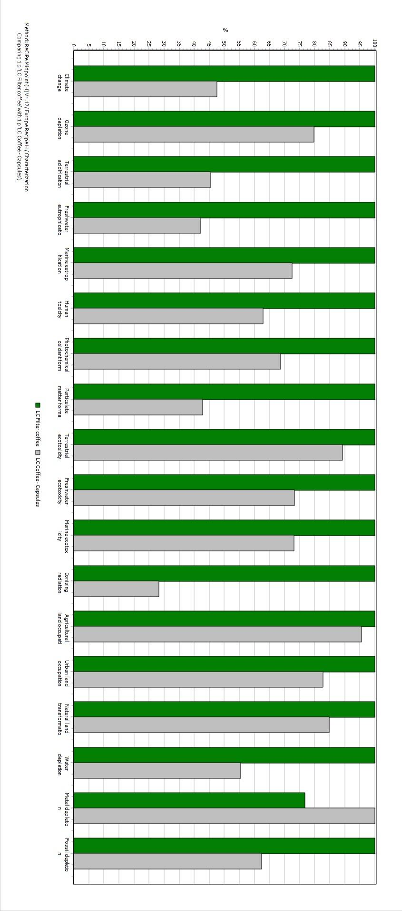
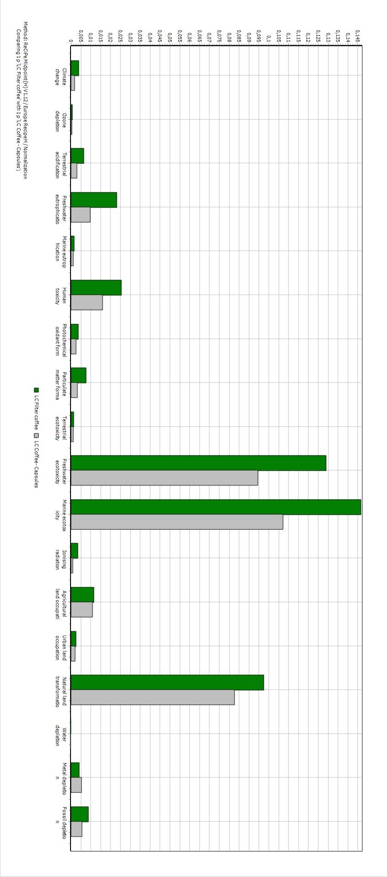

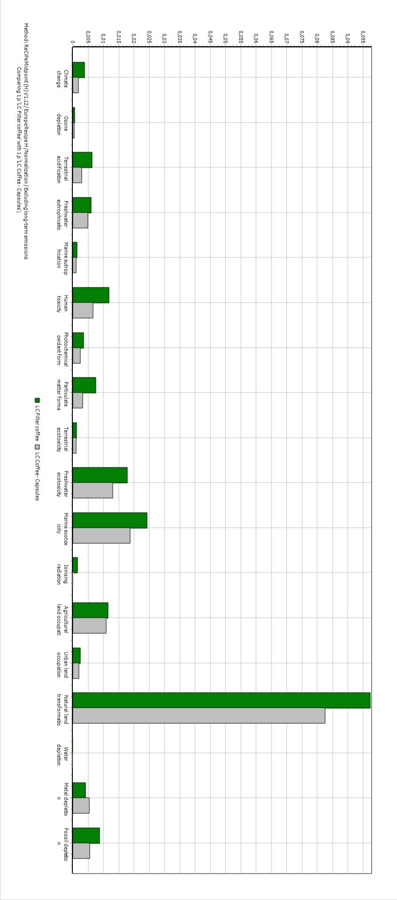

APPENDIX 3
The following figures are enlarged figures from the result, figure 6 and 8.
